Environmental Setup for React

1. Node version >= 8.10
2. NPM version >= 5.6

Let us check the current version of **Node** and **NPM** in the system.

Pause

Unmute

Current TimeÂ 1:34

/

DurationÂ 4:57

Loaded: 100.00%

Â

Fullscreen

x[](https://campaign.adpushup.com/get-started/?utm_source=banner&utm_campaign=growth_hack)

Run the following command to check the Node version in the command prompt.

1. $ node -v

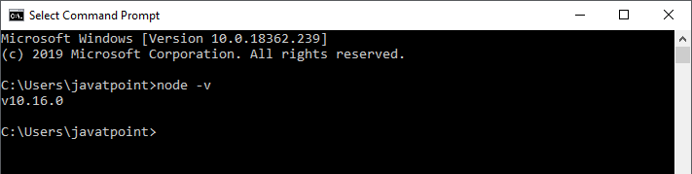

Run the following command to check the NPM version in the command prompt.

1. $ npm -v

Installation

Here, we are going to learn how we can install React using ***CRA*** tool. For this, we need to follow the steps as given below.

Install React

We can install React using npm package manager by using the following command. There is no need to worry about the complexity of React installation. The create-react-app npm package manager will manage everything, which needed for React project.



Create a new React project

Once the React installation is successful, we can create a new React project using create-react-app command. Here, I choose "reactproject" name for my project.

1. create-react-app reactproject

**NOTE:** We can combine the above two steps in a single command using **npx**. The npx is a package runner tool which comes with npm 5.2 and above version.

1. npx create-react-app reactproject

The above screen tells that the React project is created successfully on our system. Now, we need to start the server so that we can access the application on the browser. Type the following command in the terminal window.

1. $ cd Desktop
2. $ npm start

NPM is a package manager which starts the server and access the application at default server [http://localhost:3000](http://localhost:3000/). Now, we will get the following screen.

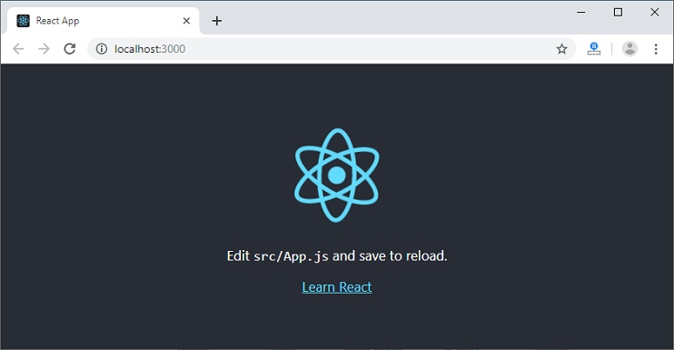

Next, open the project on Code editor. Here, I am using Visual Studio Code. Our project's default structure looks like as below image.

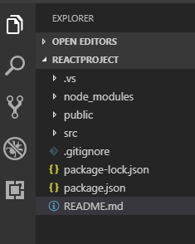

In React application, there are several files and folders in the root directory. Some of them are as follows:

1. **node_modules:** It contains the React library and any other third party libraries needed.
2. **public:** It holds the public assets of the application. It contains the index.html where React will mount the application by default on the <div id="root"></div> element.
3. **src:** It contains the App.css, App.js, App.test.js, index.css, index.js, and serviceWorker.js files. Here, the App.js file always responsible for displaying the output screen in React.
4. **package-lock.json:** It is generated automatically for any operations where npm package modifies either the node_modules tree or package.json. It cannot be published. It will be ignored if it finds any other place rather than the top-level package.
5. **package.json:** It holds various metadata required for the project. It gives information to npm, which allows to identify the project as well as handle the project?s dependencies.
6. **README.md:** It provides the documentation to read about React topics.

React Environment Setup

Now, open the **src >> App.js** file and make changes which you want to display on the screen. After making desired changes, **save** the file. As soon as we save the file, Webpack recompiles the code, and the page will refresh automatically, and changes are reflected on the browser screen. Now, we can create as many components as we want, import the newly created component inside the **App.js** file and that file will be included in our main **index.html** file after compiling by Webpack.

Next, if we want to make the project for the production mode, type the following command. This command will generate the production build, which is best optimized.

1. $ npm build

# **React Features**

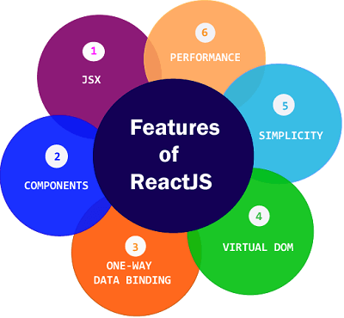

Currently, ReactJS gaining quick popularity as the best JavaScript framework among web developers. It is playing an essential role in the front-end ecosystem. The important features of ReactJS are as following.

* JSX
* Components
* One-way Data Binding
* Virtual DOM
* Simplicity
* Performance

JSX

JSX stands for JavaScript XML. It is a JavaScript syntax extension. Its an XML or HTML like syntax used by ReactJS. This syntax is processed into JavaScript calls of React Framework. It extends the ES6 so that HTML like text can co-exist with JavaScript react code. It is not necessary to use JSX, but it is recommended to use in ReactJS.

Components

ReactJS is all about components. ReactJS application is made up of multiple components, and each component has its own logic and controls. These components can be reusable which help you to maintain the code when working on larger scale projects.

One-way Data Binding

ReactJS is designed in such a manner that follows unidirectional data flow or one-way data binding. The benefits of one-way data binding give you better control throughout the application. If the data flow is in another direction, then it requires additional features. It is because components are supposed to be immutable and the data within them cannot be changed. Flux is a pattern that helps to keep your data unidirectional. This makes the application more flexible that leads to increase efficiency.

Virtual DOM

A virtual DOM object is a representation of the original DOM object. It works like a one-way data binding. Whenever any modifications happen in the web application, the entire UI is re-rendered in virtual DOM representation. Then it checks the difference between the previous DOM representation and new DOM. Once it has done, the real DOM will update only the things that have actually changed. This makes the application faster, and there is no wastage of memory.

Simplicity

ReactJS uses JSX file which makes the application simple and to code as well as understand. We know that ReactJS is a component-based approach which makes the code reusable as your need. This makes it simple to use and learn.

Performance

ReactJS is known to be a great performer. This feature makes it much better than other frameworks out there today. The reason behind this is that it manages a virtual DOM. The DOM is a cross-platform and programming API which deals with HTML, XML or XHTML. The DOM exists entirely in memory. Due to this, when we create a component, we did not write directly to the DOM. Instead, we are writing virtual components that will turn into the DOM leading to smoother and faster performance.